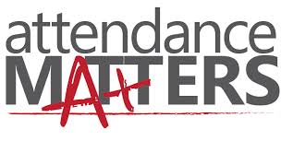

|  |  |  |  |  |
| --- | --- | --- | --- | --- |
| picture1.jpg | 0e4ad001b0d95668d88ec26f7d627c20.jpg | decisions-are-made-by-those-who-show-up-quote-1.jpg | images (2).jpg | print-of-wake-up-and-be-awesome-hand-painted-sign.jpg |
| 62MUF7MUpCvtCD10fP3B4jl72eJkfbmt4t8yenImKBVvK0kTmF0xjctABnaLJIm9.jpg | images.jpg | e852fa54cf2826bd55d74ce67ea0abad.jpg | images (1).jpg | Bu_xHr0CAAE2rgo.jpg-large |
| b125f63bfad6607b925de4305db1064a.jpg | 535519_508703099176513_173466308_n.jpg | 20131206-192808.jpg | quote_wall.jpg | 15f6e4ef269bd5e06b8d8d70fcfc06f8.jpg |
| Rise up & attack the day with enthusiasm.jpg | b33f3a0e00c17f257c7d337e8bd6a9a5.jpg | If-you-are-persistent-you-will-get-it.-If-you-are-consistent-you-will-keep-it.jpg | GoalPlanWish.jpg | 6267-1365651452257.png |
| a2d52d13928ad67b2c7a62bf67207837.jpg | actually_i_can_catalystjohn.jpg | 7a2ddc420f6ef5fdd6e5331e742d5f87.jpg | wake-up.png | 3a2087faa0855fff05817f4750f2a13d.jpg |