Hello 5th Graders and Parents!

Welcome to Enterprise Middle School for the 2017-2018 school year. I am very excited to welcome you into our school and I am sure you will find it a positive environment for learning and growing. At this point, you are faced with many decisions that will affect your school life for the next 3 years and I want to take this time to invite you to consider making band a part of that decision.

Band offers many opportunities for 6th grade students:

- 6th grade band students at EMS have many instrument choices:
  - Woodwinds: flute and clarinet (students that wish to play saxophone will first start on clarinet then switch over sometime in the spring)
  - Brass: trumpet and trombone
  - Percussion: As a percussionist in 6th grade you will be playing the snare drum and bells primarily (other percussion will be added later in the year)
  - We limit the number of instrument choices for all 6th graders on so they can first learn some basic skills. Students who have played one of the above instruments in their elementary school band program for at least one year may be able to start 6th grade on another instrument such as the French horn, bassoon, or oboe (see Mr. Miller or Mr. Simmons for details).
- We have up to 4 concerts at EMS every year.
- Each year 6th graders from around the district get to participate in the band showcase. This event will include all 6th grade band students from each of the four middle schools and provide an opportunity for them to work with the wonderful music staff and student leadership at Richland and Hanford High Schools.

This year the Enterprise Band program had over 220 students enrolled. You can ask any one of them and they’ll tell you how much fun they have playing music. Of these students, many of them also participate in sports and a high percentage of Band students are regularly on the Honor Roll, Principal’s List and Superintendent’s List for Academic Excellence. The band program provides a positive environment that gives students a wonderful opportunity to expand their horizons, learn new skills, and create memories that can last a lifetime. We would like to invite you to join our band and see how much fun it can be! Don’t miss out on this great opportunity!

Joining band is easy! Just sign up on your 6th grade registration forms to join. No prior experience is necessary. Our only requirement is that you provide an instrument (there are a limited number of school instruments available based on student need and you can see Mr. Miller or Mr. Simmons for more details). Instrument rentals are usually very affordable and to make getting an instrument easier, EMS will host an instrument rental night during the first week of school next fall for you to check things out!

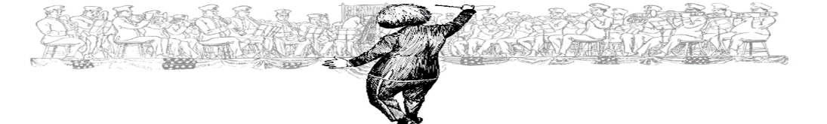

Enterprise Middle School Band Highlights 2016-2017

Veteran’s Day Parade
Eastern Jazz Festival
Elementary Tour
CBMEA Large Group Festival
RSD Band Showcase
Swing Dance
8th Grade Trip to Seattle

A Few Interesting Quotes:

“During the Gulf War, the few opportunities I had for relaxation I always listened to music and it brought me great peace of mind. I have shared my love of music with people throughout this world, while listening to the drums and special instruments of the Far East, Middle East, Africa, the Caribbean, and the Far North, and all of this started with the music appreciation course that I was taught in a third-grade elementary class in Princeton, New Jersey. What a tragedy it would be if we lived in a world where music was not taught to children.”
- General H. Norman Schwarzkopf — United States Army

“Music is exciting. It is thrilling to be sitting in a group of musicians playing (more or less) the same piece of music. You are part of a great, powerful, vibrant entity. And nothing beats the feeling you get when you've practiced a difficult section over and over and finally get it right (yes, even on the wood block). Music is important. It says things you heart can't say any other way, and in a language everyone speaks. Music crosses borders, turns smiles into frowns, and vice versa. These observations are shared with a hope: that, when schools cut back on music classes, they really think about what they're doing - and don't take music for granted.”
- Dan Rather — CBS News

“In every successful business…there is one budget line that never gets cut. It’s called ‘Product Development’ – and it’s the key to any company’s future growth. Music education is critical to the product development of this nation’s most important resource – our children.”
- John Sykes — President, VH1

“The things I learned from my experience in music in school are discipline, perseverance, dependability, composure, courage and pride in results. . . Not a bad preparation for the workforce!”
- Gregory Anrig – President, Educational Testing Service

“Music is an essential part of everything we do. Like puppetry, music has an abstract quality which speaks to a worldwide audience in a wonderful way that nourishes the soul.”
- Jim Henson – television producer and puppeteer

